Blinkit Marketing and Customer Feedback Dashboard

The Blinkit Marketing and Customer Feedback Power BI project focuses on analyzing business performance by combining marketing data, sales transactions, and customer feedback. The main objective of this project is to understand how marketing campaigns impact revenue and customer engagement, and how customer satisfaction varies across products, locations, and time. This dashboard helps business users monitor key performance indicators and make data-driven decisions to improve marketing efficiency and customer experience.
Introduction

The Blinkit Marketing and Customer Feedback Power BI project is designed to analyze how marketing activities influence business performance and how customers perceive the service through feedback and ratings. In today’s competitive quick-commerce market, understanding customer behavior and campaign effectiveness is crucial for improving sales, customer satisfaction, and overall business growth.
The main objective of this project is to evaluate the performance of different marketing channels and campaigns, measure key metrics such as revenue, conversion rate, and return on ad spend (ROAS), and analyze customer feedback trends across products, locations, and time periods. This helps identify what is working well and where improvements are needed.
The project integrates data from multiple sources including customer details, marketing performance, orders and order items, product information, and customer feedback or ratings. By combining these datasets, the analysis provides an end-to-end view of the customer journey, from marketing engagement to purchase behavior and post-purchase feedback.
Power BI is used to build interactive dashboards and reports that visualize KPIs, trends, and comparisons in an easy-to-understand format. Through dynamic filters and drill-down features, stakeholders can explore performance by campaign, channel, product, location, and time period, enabling faster and more informed decision-making.
Problem Statement
Blinkit aims to accelerate growth by identifying high-potential customer segments, high-performing locations, and the most effective marketing channels. However, scattered data across orders, customers, campaigns, and feedback makes it difficult to pinpoint where to invest for maximum growth.

- Which marketing campaigns generate higher revenue compared to their spending, and which campaigns perform best financially?
- How is the total marketing budget distributed across different channels, and which channels receive the highest and lowest spend?
- How do total sales vary across product categories, and how are these sales distributed among different payment methods?
- What percentage of orders are delivered on time versus delayed, and how can delivery performance be monitored to improve customer satisfaction?
- How does customer rating influence total sales, and which rating level contributes the most to revenue?
- Which areas generate the highest number of orders, and how does order volume vary across different locations?

Existing System

In the existing system, marketing performance, sales data, and customer feedback are maintained in separate sources such as spreadsheets, databases, or basic reporting tools. These datasets are often handled by different teams, making it difficult to obtain a consolidated view of business performance. As a result, stakeholders rely on manual reporting and fragmented insights to understand marketing effectiveness and customer satisfaction.
The existing reporting approach is mostly static and time-consuming, where reports are prepared manually on a periodic basis. This process leads to delays in decision-making and increases the risk of human errors. Since reports are not real-time or interactive, users cannot easily drill down into specific campaigns, locations, products, or time periods to identify root causes of performance issues.
In the current system, marketing metrics such as impressions, clicks, conversions, and spend are analyzed separately from sales and customer feedback data. This lack of integration makes it difficult to understand the complete customer journey, for example, how a particular campaign influences revenue or how service quality impacts customer ratings. Decision-makers do not get a unified view of how marketing efforts translate into customer satisfaction and business outcomes.
Technology Used
Excel
- Initial data inspection and formatting
- Handling missing values and basic data validation
ETL (Extract, Transform, Load)
- Extracted Blinkit Marketing and Customer feedback
- Transformed raw data into structured and analysis-ready tables
- Loaded clean data into Power BI for visualization and insights
Power BI
- Data modelling and relationship management
- Interactive dashboard development
- KPI cards, slicers, and visual analytics

Data Transformation Steps

- Renamed columns for clarity
- Removed duplicate records
- Standardized country codes and city names
- Filtered irrelevant or incomplete rows
- Created curated city lists
- Converted data types (dates, salary, numeric fields)
- Normalized salary values to USD
- Cleaned text fields (uppercase formatting)
- These steps ensured data accuracy, consistency, and usability.

Outcome:
These transformation steps ensure clean, reliable, and analysis-ready data, enabling accurate KPIs and meaningful insights in Blinkit Marketing and customer feedback.

DAX Measures
DAX (Data Analysis Expressions) is used to create calculated measures and KPIs, including Total Sales, Total Orders, Average Rating, Clicks, Conversion, Impressions. DAX allows dynamic calculations that respond to user interactions within the dashboard.

Why DAX Is Important in This Project?
DAX enables dynamic calculations that change instantly based on filters, slicers, and user interactions. It helps transform raw data into actionable KPIs and insights, making the Blinkit Grocery Dashboard more powerful and business-ready.
Example:

1. Total Sales
Total Sales = (order item (sales amount))
Explanation:
Calculates the total revenue generated from all grocery orders. This is the primary KPI to measure business performance.

2. Total Orders

No of Order =

Distinct count (order[order id])

Explanation:
Counts the number of unique orders placed by customers. Helps understand order volume and demand.

3. Average Sales
Average Sales =
AVERAGE (order item (sales amount))

Explanation:
This measure calculates the average sales value per transaction by taking the mean of all individual sales amounts. It helps understand the typical sale size across orders.

4. Average Rating
Average Rating =
AVERAGE (customer feedback[rating])
Explanation:
Calculates the average customer rating across all orders or deliveries. Useful to measure overall customer satisfaction.
Data modelling

This data model follows a Snowflake Schema. In a snowflake schema, dimension tables are normalized and connected to other dimension tables, forming multiple levels of relationships around a central fact table.

Why This is Snowflake
Your fact-like tables:
- orders (order id, order date, delivery status, payment, days to deliver)
- order items (order id, product id, quantity, sales amount)
- customer feedback (ratings, sentiment, feedback date)
Your dimension tables:
- customers (customer details, location, segment)
- products (product name, category, price)
- marketing performance (campaign, impressions, clicks, conversions, revenue)

Here, order items links to products, and orders links to customers and customer feedback.
Dimensions are not directly connected to one single fact only—they branch out, which creates a snowflake shape instead of a simple star.

Structure Explanation
- orders is the central transaction table.
- Order items breaks each order into product-level details.
- products is connected to order items (product dimension).
- customers is connected to orders (customer dimension).
- Customer feedback is connected to orders/customers (feedback dimension).
- Marketing performance is a separate fact table for campaign analysis.

Dashboard Landing Page

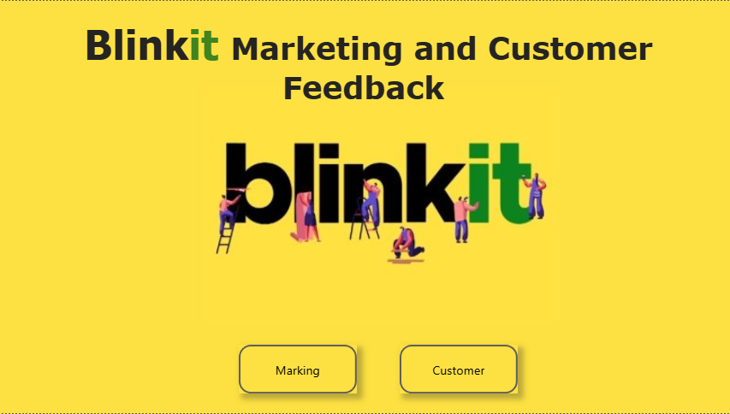
First page:

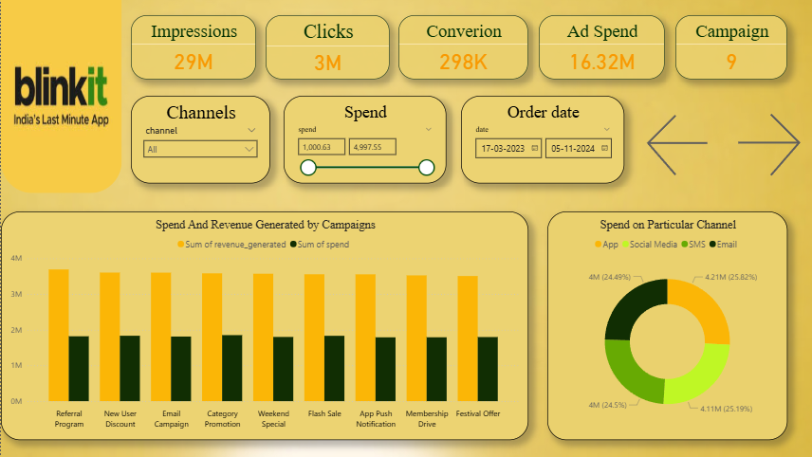
Last page:
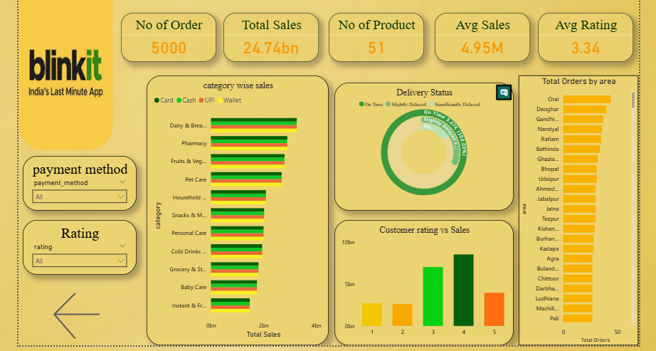

KPI summary
In Power BI, a KPI summary is essentially a high-level overview of Key Performance Indicators (KPIs) that helps users quickly understand how well a business, process, or project is performing against its goals. It is usually presented in a dashboard or report format and highlights whether targets are being met.

Impressions (29M)
Meaning:
Impressions show how many times your ads were displayed to users across platforms.

Clicks (3M)
Meaning:
Clicks represent how many times users clicked on your ads. It shows engagement level with the marketing content.

Conversions (298K)
Meaning:
Conversions indicate how many users completed a desired action (purchase, signup, app install, etc.) after clicking the ad.

Ad Spend (16.32M)

Meaning:
Ad Spend shows the total money spent on running marketing campaigns.

Campaigns (9)
Meaning:
This represents the total number of marketing campaigns currently running or analyzed in the dashboard.

No. of Orders (5000)
Meaning:
This KPI shows the total number of orders placed by customers in the selected time period.

Total Sales (24.74 bn)
Meaning:
Total Sales represents the total revenue generated from all customer orders.

No. of Products (51)
Meaning:
This shows the total number of distinct products sold or available in the dataset.

Average Sales (4.95 M)
Meaning:
Average Sales indicates the average revenue per order or per product (based on known definition in the model).

Average Rating (3.34)
Meaning:
This KPI shows the average customer rating given to products or services.

Chart Used
Power BI charts are visual representations of your data in the Power BI tool, designed to help you understand trends, patterns, and insights quickly. They transform raw data into interactive visuals that can be filtered, drilled into, and explored.

1. Purpose of Power BI Charts
- Visualize data: Make large datasets easier to understand.
- Track KPIs: Monitor key performance indicators.
- Spot trends & patterns: See changes over time or across categories.
- Interactive reporting: Users can click, filter, or drill down for deeper analysis.

1. Spend and Revenue Generated by Campaigns

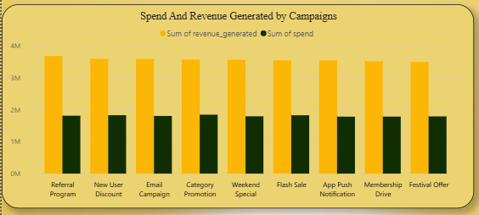

- Chart - Clustered Column Chart
- X-axis – campaign name
- Y-axis – sum of revenue generated,
sum of spend

This clustered column chart compares marketing spend with revenue generated across campaigns. It helps identify which campaigns deliver higher ROI, optimize budget allocation, and improve overall marketing performance.

2. Spend on Particular Channel

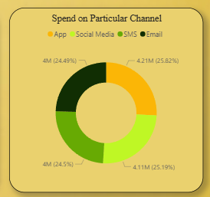

- Chart - Donut Chart
- Legend – Channel
- Value – sum of spend

This donut chart shows how total marketing spend is distributed across channels like App, Social Media, SMS, and Email, helping stakeholders understand budget allocation and optimize spending based on performance.
3. Category wise Sales

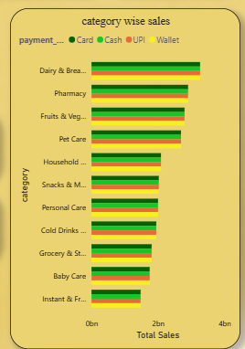

- Chart - Clustered Bar Chart
- Y-axis – Category
- X-axis – Total Sales
- Legend – Payment method

This clustered bar chart shows category-wise sales split by payment methods like Card, Cash, UPI, and Wallet, helping analyze top-performing categories and customer payment preferences.
4. Delivery Status

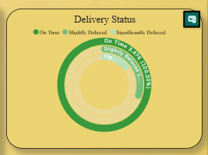

- Chart – Actively Gauge
- Category – Delivery Status
- Values – Count of Order id

This donut chart shows the percentage of orders delivered on time versus delayed, helping monitor delivery performance and improve customer satisfaction.

5. Customer Rating VS Sales

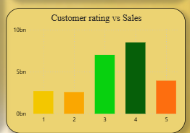

- Chart - Stacked Column Chart
- X-axis – Rating
- Y-axis – Total Sales

This chart shows the relationship between customer ratings and total sales, highlighting that higher ratings, especially 3–4 stars, contribute significantly more to revenue, proving the impact of customer satisfaction on business performance.

6. Total Orders By Area

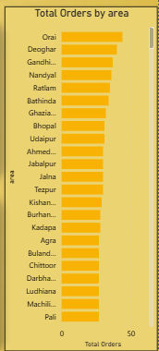

- Chart - Clustered bar Chart
- X-axis – Area
- Y-axis – Total Order

This bar chart shows total orders by area, helping identify top-performing cities and understand geographic demand patterns for better logistics and marketing decisions.

Conclusion

The Blinkit Marketing and Customer Feedback Power BI dashboard provides a comprehensive and interactive analytical view of the organization’s overall business performance by combining marketing data, customer feedback, sales performance, delivery operations, and geographic demand into a single unified platform. By integrating multiple data sources such as campaigns, channels, orders, customer ratings, delivery status, product categories, and locations, the dashboard enables stakeholders to gain a 360-degree view of business operations. This centralized reporting system reduces manual reporting efforts and supports faster, more accurate decision-making.

